# User Manual for P2

CSCI 6461 Group 10 (2024 Fall)

1. **The User Interface**

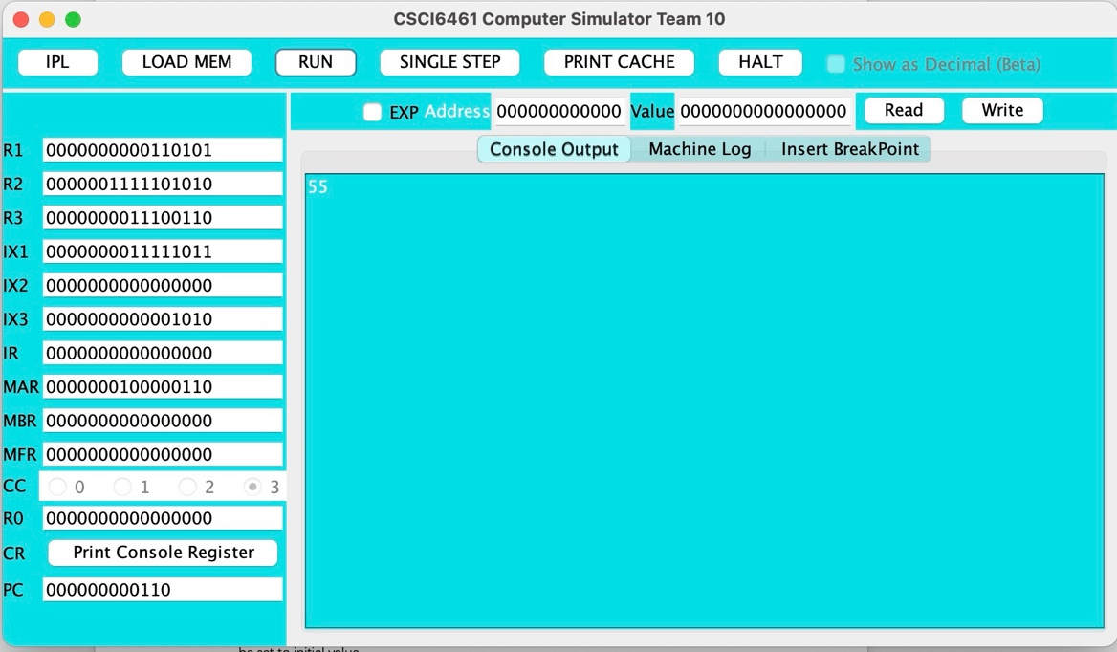

Figure 1: The User Interface of the simulator

**Control Area**

* **IPL Button** : Resets the Simulator
* **Run Button**: Executes the program file
* **HALT Button**: Halts the program
* **SINGLE STEP Button**: Executes one instruction at a time.
* **LOAD MEM Button** will read a CSV file and load the value to the memory.
* **PRINT CACHE Button** Print cache to “Machine Log”

**Register Field**

* Register values are editable except IR, MFR, CC
* Type the value and press <Enter>.
* Print Console Register Button Prints all the console register data to the “Machine Log”.

**Console Output**

* Prints the result of the program

**Machine Log**

* Prints logs and state of machine

.

1. **Operate the simulator to Testing Program 1**

Create a program that reads 20 integers (ranging from 0 to 65,535) from user input, displays them, then asks the user for target number. The program should find and display the closest number from the list to this entered number.

**To run this testing program, follow the step below:**

* Open the JAR file, and click the “IPL” Button.
* Press “LOAD MEM” Button, and select the testing program 1 CSV file. (Team 10 TestingProgram1 P1 CSCI6461Section10Fall2024November022024.csv)
* Press “RUN”
* Input 20 numbers
* Enter the target number and console output will display the number closest to your target number from the given list of 20 numbers.